Shortages of medical personnel in emergency departments and unexpected closures

Policy-in-Action Project: Analytical and Methodological Scoping Plan

École Polytechnique
Louise GATTY, Bianca MORANO DONATI, Anahí REYES MIGUEL, and Arne UHLENDORFF

1. Background and Motivation
The rate at which the number of emergency physicians has grown in France over the past decade (around +20%), exceding the growth in the number of emergency room visits (+9.1%). Despite this overall increase in staffing, hospitals continue to experience shortages that have led to partial or complete closures of emergency departments.
This apparent contradiction suggests that the issue may not stem from an overall lack of physicians, but rather from an unequal distribution of medical resources across regions (les déserts médicaux) and hospital types.
The project therefore seeks to:
- Describe the current state of shortages of emergency physicians across hospitals and regions (cross-sectional analysis 2014 vs 2024).
  - Using (1) doctors-to-visits ratio and (2) emergency departments-to-visits ratio as proxies for shortages.
- Examine whether these shortages can be explained by structural or geographic imbalances (e.g., hospital type, size, or location).
- Assess how staffing shortages are linked to the frequency and duration of partial or full closures of emergency departments (2024).

2. Research Questions

Main question
- How do staffing levels in emergency departments relate to the occurrence of partial or full closures, or regulated access, in 2024 in France?
Secondary questions
- How are characteristics such as legal status, geographic location, or hospital size associated with partial or full closures?
- Are hospitals with low doctor-to-visit ratios more likely to experience closures or regulated access? Are départements with low emergency departments-to-visit ratios more likely to experience closures or regulated access?
- How has the distribution of emergency department staffing evolved between 2014 and 2024 (cross-sectional analysis), and in which areas have the situation deteriorated or improved (panel analysis if possible)?

3. Data Sources

The following section presents the datasets that will be used in the project, combining existing official sources with a new dataset to be created by the team. The newly created dataset will be referred to as the EDCD (Emergency Department Closures Database).

Dataset | Description | Access | Purpose in analysis
Emergency Department Closures Database (LLM-assisted collection) | Regional announcements of partial/full closures or regulated access. | Public web sources (Agence Régionale de Santé, local newspapers, hospital websites, and any other information available online) | Answer main RQ; Build an exhaustive database of closures and regulations starting in 2023.
SAE (Statistique Annuelle des Établissements de Santé) | Annual survey of hospitals with staffing and activity indicators | Open data (DREES) | Compute doctor-to-visits and emergency departments-to-visits ratios, identify low-staffed services for 2014 and 2024; much more information on the hospital.
Enquête Urgences 2023 | Detailed staffing snapshot on a specific day (three time slots: morning, evening, night). | Structure module open; HR module pending agreement | Counterpoint the SAE; Cross-validate EDCD in 2023: staffing measures and capture daily patterns; full description of emergency structures.
RPU (Résumé de Passage aux Urgences) | Individual emergency visits (?) | Confidential (Onyxia) | Detect closures through drops in activity?; cross-validate closure database 2023-2024; as a control
FINESS | Registry of health establishments containing hospital identifiers, type, and legal status. | Open data | Link datasets and categorize establishments
INSEE contextual data | Geographic and socioeconomic indicators | Open data | Obtain geodata and contextual covariates.

Relevant variables and comments for the SAE database:
- Section: STRUCTURE DES URGENCES GENERALES
  - A18 : Nombre total de passages aux urgences dans l’année.
  - A19 : des patients de plus de 80 ans
  - A20 : des patients de moins de 18 ans
  - Subsection: Personnels affectés à la structure d’urgence, contribuant à l’activité décrite
    - F30 – E39 : sur personnel salarié
- Section : Activités de soins soumises à autorisation
  - URGENCES : Structure des urgences
  - SMURSAMU (Services Mobiles d’Urgence et de Réanimation / Services d’Aide Médicale Urgente) : hospital services authorized to operate these emergency and resuscitation units.
- Section: PCAMEDURG for 2024 only
  - Human resources variables for emergency services in 2024.
- Section/Question: Q20 — Personnels médicaux (hors internes) des établissements sanitaires par spécialité exercée

General comments:
- Staffing coverage
  - The analysis will use data from both salaried and self-employed (liberal) physicians to capture the total medical capacity available for emergency care.
  - He mentioned some hypothesis.
- Scope of emergency departments
  - Include general and pediatric emergency departments.
- Data caveat
  - Some emergency physicians are classified under general medicine rather than the dedicated emergency category, potentially leading to underestimation of ER staff.
  - This will be addressed through a critical analysis of the survey data and possible adjustments (as suggested by DREES).
- Source specificity
  - The URGENCES bordereau (report/form) is the main source of staffing and activity data for emergency departments.

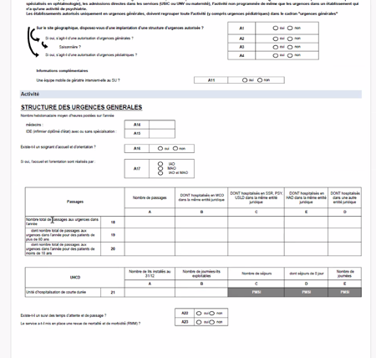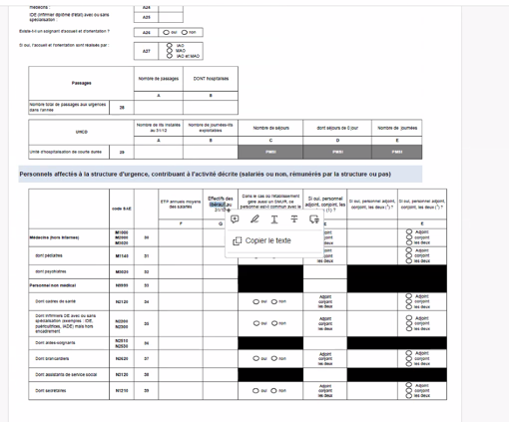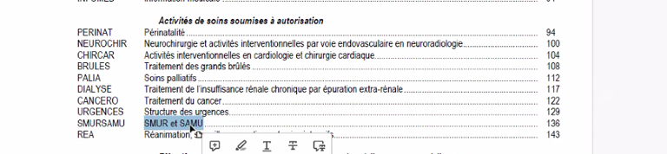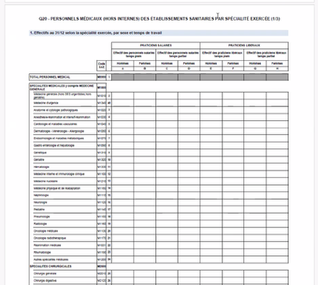

Relevant comments for l’enquete urgence database:
- A single FINESS establishment may correspond to multiple emergency structures, typically one general emergency department and one pediatric emergency department.
- Each of these services completes a separate questionnaire, meaning that the number of survey responses exceeds the number of hospital identifiers (FINESS).
- This distinction is important when merging or comparing with the SAE dataset, as a single hospital can appear more than once in the Enquête Urgences data.

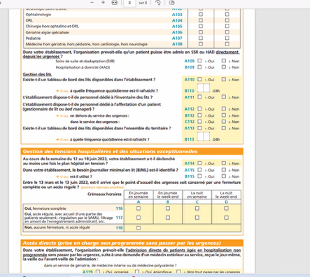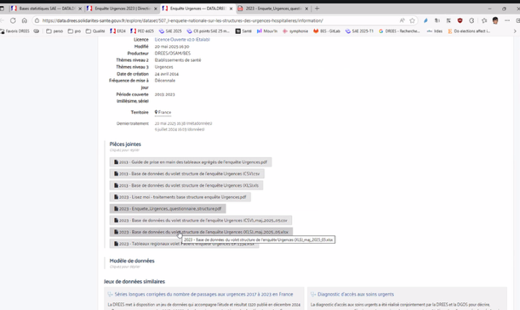

Relevant comments for the RPU database:
- Granularity and coverage
  - The RPU provides the number of emergency visits per day and per emergency department (identified by the hospital’s FINESS code).
  - This makes it possible to analyze daily activity trends and detect potential anomalies or drops in patient volume.
- Limitations for detecting closures
  - The dataset does not explicitly indicate whether a service was closed.
  - On certain days, a department may report no data — this could mean either:
    - the emergency department was closed, or
    - the data were not transmitted or recorded.
  - Therefore, days with zero activity must be interpreted cautiously and cross-checked with other sources (e.g., ARS announcements, Enquête Urgences 2023).
- Regulated access (partial functioning)
  - When an emergency department operates under regulated access (e.g., only specific cases admitted), the RPU may still show activity, but at lower volumes.
  - This makes it difficult to distinguish between true closures and restricted operations using RPU data alone.

Building the Emergency Department Closures Database (LLM-assisted collection)
This database will be created by collecting information from the websites and publications of the Agences Régionales de Santé (ARS) and local press starting in 2023, where announcements of partial or full emergency department closures or regulated access are regularly posted.
Our goal is to develop a prototype of an LLM-assisted data collection process, implemented as a Python pipeline deployed on the Quetzal cluster. This pipeline utilizes automated, domain-restricted search queries and runs a locally hosted Large Language Model (Mistral-7B-Instruct-v0.3). To ensure high throughput and cost-efficiency, the model is served via the vLLM inference engine, which optimizes GPU memory usage through PagedAttention and KV caching. This setup identifies and extracts closure announcements without relying on paid external APIs.
In practice, this process involves a Python notebook (utilizing a specialized vllm_env Conda environment) to:
- Execute targeted search queries for each hospital (e.g., site:fr "fermeture urgences" [Hospital Name] 2024) using open-source tools to retrieve text content.
- Process the retrieved texts using the Mistral-7B model hosted directly on local RTX A5000 GPUs. The model is stored on the cluster's high capacity /Data partition to manage disk quotas effectively.
- Instruct the model, via designed prompts, to extract key fields into a strict JSON format.
- Store the structured outputs in a reusable dataset file.
The LLM will extract and return a structured dataset containing preliminary key variables such as:
- Hospital or facility name
- Region and department
- Type of closure (partial, full, or regulated access)
- Start and end dates (or time periods)
- Reason for closure (e.g., staff shortage, renovation)
- Source reference (URL and publication date)
Validation and Software Compliance: While the collection pipeline is built in Python to leverage the high-performance vLLM serving capabilities, the resulting output will be imported into R for all subsequent steps. The data will be cross-validated in R against RPU daily activity data and the Enquête Urgences 2023 to assess completeness and accuracy, ensuring full alignment with DREES technical preferences.

Key Technical Changes Made:
- Location: Changed "Onyxia Datalab" to "Quetzal cluster" to match your SSH login.
- Serving Engine: Specifically mentioned vLLM, as this is a more advanced and faster way to run Mistral than standard Hugging Face loading.
- GPU Details: Included the local hosting on GPUs to reflect the nvidia-smi status you verified.
- Storage Logic: Subtly added the part about the /Data partition, which was the solution to your disk problems.
Would you like me to help you write the Python code for the "Instruct the model" part so it outputs the JSON format you mentioned in the text?

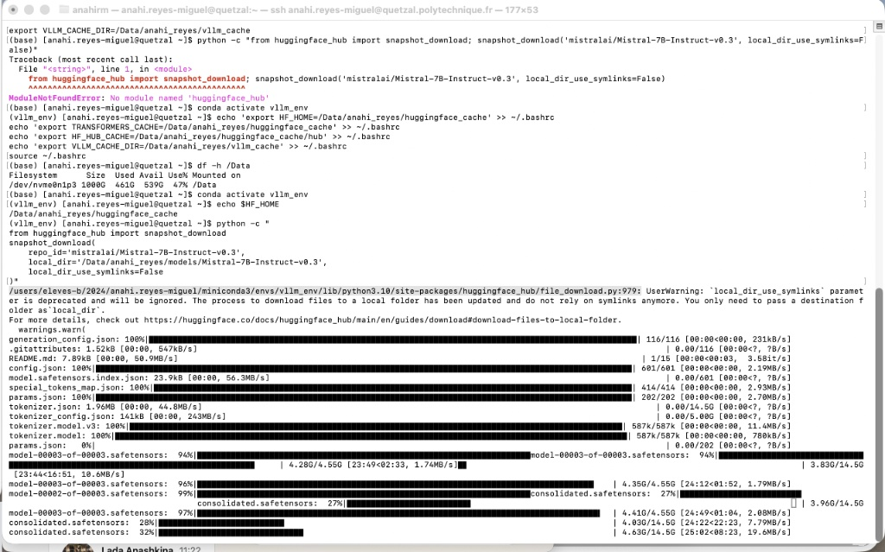

Additional question for SAE (Statistique Annuelle des Établissements de Santé):
What does a “critical analysis of survey data” entail? Is this related to a lack of data on ER personnel?
- “Les données de passages aux urgences de ces bordereaux étant très contrôlés, mais un peu moins celles concernant les personnels concourant à l’activité (PCA) des services d’urgence, ce sera déjà l’occasion d’analyser de façon critiques des données d’enquête (voir de proposer des redressements statistiques dans les cas les plus avérés). “
  - How is the respondent (ETP – Équivalent Temps Plein) expected to answer the questions? Are there better ways to elicit the answers?

4. Variables

Unit of analysis & time
- Primary unit: Emergency department (hospital/structure level).
- Primary time scale: Annual (2024 cross-section for the core; 2014 added only if readily available and comparable).
Dependent variable (Y):

Variable | Definition | Source
any_restriction | 1 if the ER experienced any service restriction in the year (partial closure, full closure, or regulated access); 0 otherwise. | EDCD
Additional Ys:
- closure_only (excludes regulated access).
- restriction_days (count of calendar days with restriction; use only if dates are complete and validated).
- regulated_access_only.
Key independent variables (X): ratio of doctors per capita

Category | Variable | Role | Operational note | Source
Staffing | doctors_ratio | Measure of relative staffing (availability per patient load) | FTE_doctors_ER / visits_ER | Derived from SAE
 | visits_ER | Measure of demand or workload | Annual ER visits | SAE
 | FTE_doctors_ER | Direct measure of staffing capacity | Annual FTE emergency physicians (as reported) | SAE
Organization | legal_status | Captures institutional characteristics that may affect staffing and closure | Public / ESPIC (non-profit) / Private for-profit | TBD
Size | ER_volume_quartile | Controls for hospital size and patient volume | Quartiles of annual ER visits (size control) | Derived from SAE
Geography | Region/Departement | Accounts for regional effects and territorial disparities | Administrative region fixed effects | SAE/FINESS
 | urban_rural | Captures local context and accessibility | Simple urban/rural indicator if readily matched | INSEE

5. Analytical Approach

The main cross-sectional analysis focuses on 2024, while 2014 provides a historical reference point for staffing evolution, and 2023 serves as a validation year for the EDCD and related datasets using R.
- Descriptive statistics (cross-sectional 2014 vs 2024)
  - Distribution of staffing ratios by region and legal status.
  - Identify departments with lowest doctor-to-visit ratios.
- Validation of closure data:
  - Cross-check EDCD-LLM records with RPU daily volumes and Urgences 2023 survey.
  - Evaluate exhaustiveness (coverage) and error rate (false positives/negatives).
- Exploratory correlation / risk analysis:
  - Assess whether low staffing correlates with higher probability of closure.
  - If not, test other risk factors (legal status, geography).
  - Possible models: logistic or probit regressions, descriptive cross-tabs, and/or clustering of high-risk areas (if time allows it).
- Visualization & communication:
  - Produce regional dashboards/maps (doctor ratios, closures, regulations).
  - Summaries by region, sector, and year.

6. Expected Deliverables
- October 2025: Analytical and methodological scoping plan.
- January 2026: Interim presentation with preliminary descriptive findings and an overview of the EDCD.
- April 2026: Final presentation with findings, and the repository with R and Python codes, and their technical documentation.

7. Timeline
Phase | Period | Objectives | Outputs
Kick-off & scoping | Oct 2025 | Confirm research scope and data access | Meeting summary
Data collection & cleaning | Nov - Dec 2025 | Gather SAE / Urgences / ARS data; start LLM extraction | Cleaned datasets
Intermediate analysis | Jan 2026 | Descriptive statistics, staffing ratios, first maps, EDCD Database | Interim slides
Validation + Modeling | Jan–Mar 2026 | Cross-check with RPU; run risk analysis | Notebook report
Finalization | Apr 2026 | Write and present final results | Final report & presentation

